**VOLUME OF BOX**

import math

length=float(input("Enter the length of a box"))

volume = length*length*length

print(volume)

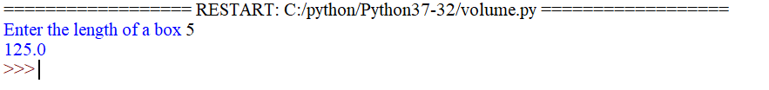

**VOLUME OF EARTH**

import math

PI = math.pi

r = 6.4*10**6

vol = 4/3*PI*r**3

print("VOLUME OF EARTH IS ", vol)

